Obada alhalaybeh-23110107

Nayef Abu-Aqeel

Abstract

T This report explores the development of an AI-powered medical imaging system for a hospital. The system is designed to work alongside radiologists by retrieving relevant patient history and analysing scans such as X-rays, MRIs, and CT images. Using advanced image recognition, it can highlight possible abnormalities and speed up diagnosis, helping doctors make quicker and more informed treatment decisions. The goal is to improve accuracy, reduce delays, and ensure patients receive the right care at the right time.

Technical Report

Jamile Altotanji Hospital

# **Introduction**

Artificial Intelligence (AI) is a newly emerging area of computer science that involves giving computing machines the ability to mimic human intellectual powers like learning, reasoning, problem-solving, and decision-making, and it is therefore the root of 21st-century technological innovation [1]. In health care, AI has indicated immense ability to rationalize hospital work flow and augment clinical efficiency by automated electronic health records (EHR) documentation and aid to decision procedures, relieving clinician burnout, and aiding quality care to patients [2]. They have been increasingly utilized to aid physicians in faster and more precise diagnosis, allow personalized therapy protocols, and aid patient–physician communication [3]. Studies further describe that AI deployments impact a vast array of hospital operations, from clinical decision support systems, medical image processing, monitoring patients by wearable technologies, to general operation streamlining, and therefore act as an impetus to changing the face of health care [4]. While realizing such advantages, concerns surrounding keeping data confidential, biasing by algorithms, patient safety, and unequal access to AI-based solutions abound, and therefore strict ethics guidelines and regulation become imperative to allow equally secure use of AI in health care facilities [5][6].

Healthcare professionals can use a tremendous array of AI-based tools, applications, and technologies to offer better patient care, more efficient workflows, and clinical decision support. Some of these other good examples include Electronic Health Record (EHR) systems with built-in AI that can automatically fill out entries for data feeds, identify anomalies, and offer predictive analytics on patient outcomes. Artificial Intelligence (AI)-based Clinical Decision Support Systems (CDSS) review patient data and suggest evidence-based therapies in real time. One very fast-growing category is AI-based medical imaging software that can analyze automatically X-rays, CT scans, and MRIs detection of subtle anomalies with high accuracy more quickly with a reduction in diagnostic errors. Some of these other applications such as predictive analytics are able to predict admissions and reduce the level of staffing accordingly, while AI-powered algorithm and wearable sensor and remote monitoring technology can track continuously health decline and identify it earlier. These imaging-related capabilities are extremely transformational AI-based imaging applications have been shown to speed up identification but improve accuracy in radiology and cardiology specialties. [7][8]

Artificial Intelligence is a game-changer because it revolutionizes operational efficiency throughout the healthcare landscape with automated processes, shortening diagnostic times, and enhancing medical decision accuracy. AI-powered image technologies like computer-aided radiology software and machine learning-powered CT scans, MRIs, and X-rays have decreased image interpretation times considerably, enabling clinicians to examine more cases without sacrificing quality. Research has proven that AI-powered imaging solutions can spot anomalies like cancer growth or fractures sooner than manual tests, decreasing misdiagnoses and accelerate treatment planning. Such solutions also prioritize high-priority cases by alerting important findings for early review, prioritizing patients with life-threatening diagnoses. Beyond diagnostics, AI maximizes operational efficiency by lowering repeat imaging sessions, eliminating human errors, and enabling radiologists to spend more time on tough cases than routine analysis. Throughout the entire healthcare continuum, this means shorter hospital stay times, enhanced patient flow, and lower overall costs. To the imaging sector, AI adoption is rewriting radiology departments as high-performance departments where faster, more precise image analysis dictates radiologic outcomes as well as hospital outcomes.[7][9]

In spite of the vast advantages of Artificial Intelligence in healthcare, especially in medical imaging, hospitals are still grappling with fully adopting these technologies efficiently. Integration of the technology with current hospital information systems, high costs of installing embracing the technology, need for specialized professionals for personnel training, issues of data privacy and dependability slow down or discourage the adoption of implementing the AI technology. To learn more about these issues with their solutions in better detail, this technical report centers Jamile Altotanji Hospital in examining the application of AI-based imaging solutions in enhancing efficiency in diagnosis and patient outcome in terms of operational hurdles. It is geared towards subjecting the effect of adopting AI imaging technology adoption on hospital operational streams to test, underlining determinants of an efficient adoption, to assess whether such a technology can at the same time improve hospital's clinical decision-making efficiency with overall operational efficiency within an institution.

# **Organizational Study**

## **Identify the organization**

For my idea I had to look for hospitals around Amman, that has experience in imaging in general like the X-ray, CT-scan and so on. I found that jamile Altotanji hospital fit the description I had on my mind and what helped me more that I have a relation with some of the employees there that made it easier to contact them and ask for help from them. The communication was done via phone calls and in person meeting. The survey was sent via WhatsApp.  


## **Features and the operational areas of the selected organization**

Jamile Altotanji Hospital is a medium-sized center of healthcare offering a whole spectrum of general medicine and surgery, emergency services, and advanced diagnostic imaging facilities like X-ray, CT, and MRI. The hospital is patient-focused, with well-trained medical staff and use of advanced technology to maximize diagnosis and treatment efficiency. The hospital uses modern imaging modalities and Picture Archiving and Communications System (PACS) for safe archiving of imaging data and fast sharing among departments. Besides its focus on safety and quality, the hospital boasts an efficient appointment and reporting system, which saves patient waiting-time and ensures healthcare standard compliance. All these features put together make it possible for the hospital to provide timely, accurate, and high-quality medical services to the patients.

**Support for the Organization’s Purpose**

Hospital operation design is designed to facilitate its mission towards providing precise, effective, and patient-centered healthcare. Through coordinating the advanced imaging technologies, secure IT infrastructure, and streamlined administrative flows, Jamile Altotanji Hospital aims towards technological strength in diagnostic work as well as patient-centered work. The operation departments all converge in the strategic goal of hospitals towards improving healthcare provision, where precise diagnosis means better planning towards care and better outcomes for patients. The issue is particularly applicable when designing the integration of Artificial Intelligence (AI) technologies in medical imaging as it provides the platform towards enhancing diagnostic efficacy, preventing human errors, and optimization towards resource utilization by the hospital.

Operational Areas Supporting the Hospital’s Purpose

1. Radiology and Imaging Department (Production & Quality)  
   Radiology Department is the heart of the hospital's mission via precise and on-time diagnosis. With state-of-the-art imaging equipment and experienced radiologists, the department is able to perform all the scans of high quality. Ai-based imaging integration may increase productivity again through computerized abnormality detection, quicker priority to emergency cases, and reporting time reduction.
2. Information Technology (IT) Department  
   IT Department meets the hospital's digital requirements, managing systems such as PACS and EHR to enable safe and efficient data operations. It is critical in harmonizing solutions involving AI into regular work procedures, maintaining data confidentiality, and healthcare law compliance. The department enables work sharing across departments and facilitates data availability on a real-time basis for use in decision making on a clinical level.
3. Administration and Finance  
   Administration and Finance Department is responsible for proper functioning through scheduling management, divisional coordination, and the allocation of financial resources. It also plays a key role in the evaluation of the cost-effectiveness of using AI imaging tools, procurement, and funding. Strategic control through this department guarantees budget- and mission-oriented employment for the long term through the use of AI.

## **Stakeholders**

Stakeholders are a critical factor when assessing the effectiveness or not of applying an AI-based medical imaging system in Jamile Altotanji Hospital. They all have direct roles on decision making, system application, and system performance over a long term.

Internal Stakeholders

Internal stakeholders are people or groups within the organization who are directly involved in its operations and decision-making processes. They influence and are influenced by the hospital’s performance from the inside, such as management teams, employees, and department heads.

1. Head of the Radiology Department  
   Being responsible for radiology operations with CT, MRI, and X-ray usage, this stakeholder will determine the impact on reporting speed, workflow, and accuracy of diagnosis. Its validation is important to ensure the radiologists will accept and utilize the system under normal usage.
2. IT Systems Manager  
   Oversees the hospital’s PACS (Picture Archiving and Communication System) and EHR (Electronic Health Records). This role ensures the AI imaging software is integrated securely, complies with health IT standards, and operates without disrupting existing systems.

External Stakeholders

External stakeholders are individuals or organizations outside the hospital who are affected by its services or have an impact on its success. They do not work within the hospital but can influence or be influenced by its operations, including patients, suppliers, regulatory bodies, and the local community.

1. Medical Equipment and Technology Supplier(like ibn Sina)  
   The company provides the hospital with medical imaging products, support, and integration programs. In providing the AI imaging program, the company assures hardware compatibility, offers installations, and offers technical support and training.
2. Government Health Authorities(health ministry)  
   The government, via the Ministry of Health, oversees healthcare standards and adherence to patient data privacy regulations and medical device approvals. They play an important part in approving AI systems, establishing guidelines for use, and perhaps providing funding or incentives for the uptake of new technologies.

**Impact on Project Success**

The acceptance by clinical staff will be led by the Head of Radiology, and easy integration as well as data security will be managed by the IT Systems Manager. The medical equipment and technology provider will provide full support and functionality of the AI imaging solution, while the government health authorities will ensure regulatory approval and compliance. All the stakeholders will be aligned so that the effective implementation of the AI imaging system happens in conjunction with safety and quality controls as well as the desired impact on patient care.

## **Challenges to the success of the organization's business**

1. Change Management and Staff Adaptation  
   Implementation of AI in radiology imaging requires significant alterations of current radiology departmental workflows. Some radiologists and imaging technicians will resist the acceptance of new technologies since they may fear they will lose their jobs, have no experience to use AI devices, or are against traditional methods of diagnosis. Effective management of changes will imply effective communication of the benefit, well-organized training programs, and ongoing support such that all staff will be motivated and equipped to use the new system.
2. Compliance with Legislation and Industry Standards  
   Hospitals would have to adhere to national laws and regulations of healthcare and data privacy rules of the Ministry of Health. AI radiology software would have to conform to regulatory clearances of medical devices, handling of patients' information, and industry-standards-readiness such as DICOM (Digital Imaging and Communications in Medicine) for medico-image compatibility. Delay in regulatory clearance/certification might slow down the implementation process.
3. Market Competition and Patient Expectations  
   Public and private facilities are investing more in the best available health diagnostic technology. Companies can capture additional patients by providing results more quickly and more diagnostic information if they install AI imaging more rapidly. Patients are becoming more sophisticated about health technology and might demand the same capability from the Jamile Altotanji Hospital. Failing to provide such expectations could result in declining patient satisfaction and market share loss.

## **Business Requirements**

1. Technology and Integration  
   AI image system should be able to automatically detect pathology like fractures, tumors, or hemorrhage on X-rays, CT scans, and MRI scans. It should produce readable, understandable image reports to physicians and offer predictive analysis of the course of disease. The system must seamlessly fit into the current PACS and EHR system of the hospital to enable smooth flow of information across departments.
2. Budget and Financial Constraints  
   The hospital is taking the budget of $80,000 to $120,000 to install. The budget must include the system capability, integration cost, and license program. The ultimate budget will also be guided by the system capability in reducing diagnostic time, reducing operation costs, providing quality in vendor support, reducing future maintenance costs.
3. Implementation Timeline  
   Installation is scheduled by the hospital 4 to 6 months from approval. The time span will provide ample time to interface with current systems, train staff, and validate regulatory processes. The time span must also provide the minimum disruption of on-going hospital operations.
4. Scope and Quality Requirements  
     
   The AI system must be able to offer high diagnostic accuracy to prevent false interpretation and maintain the hospital's standards. It must possess features for prioritization of emergencies, predictive analytics, and in-depth reporting that will be useful to specialists as well as referring physicians. The system must also be intuitive to make it easier for medical staff across departments to adopt it.
5. Regulatory and Compliance Requirements  
   Before deployment, the system must be certified for medical use and comply with both local and international healthcare regulations. It should also meet all patient data privacy requirements and adhere to technical standards such as DICOM to ensure compatibility with the hospital’s imaging technology. Ethical guidelines must be followed, including maintaining human oversight in AI-driven diagnoses and ensuring transparency in decision-making.

# **Research Study**

## **Research Overview**

Carry out small-scale research by applying qualitative and quantitative research methods (e.g. surveys) to generate relevant primary data. You need to detail the research methodology and sampling techniques you employed in your research. Make sure to add the survey link and interview questions in this part. Discuss how your research was conducted in an ethical manner.

This research employed a mixed method using qualitative and quantitative approaches, with the goal of providing timely evidence towards a potential use of an AI-based medical imaging system in Jamile Altotanji Hospital.

* Quantitative research involves collecting and analyzing numerical data to identify patterns, trends, and measurable outcomes.  
  I employed quantitative research in this research with a standard survey of physicians using multiple choice and Likert scales to determine their opinion, needs, and preferences in using AI imaging software.
* **Qualitative research** focuses on collecting descriptive, non-numerical data to gain deeper insights into experiences, perceptions, and motivations.  
  In this project, qualitative research was applied through a **management survey** that included open-ended questions to capture detailed requirements, risks, and considerations for AI adoption.

**Sampling Technique**

Sampling is the process of selecting a subset of individuals from a population to represent the whole group in research.  
  
In this project, the sampling method employed here was purposive sampling, whereby the participants were chosen deliberately based on the fact that they possess relevant experience and knowledge in the hospital's imaging workflows or decision-making.

Doctor survey: With 18 doctors of various specialisms (surgeons, radiologists, pediatricians, and general practice) and years of experience, in order to create a broad spectrum of opinion.

Management Survey: Contains influential decision-making individuals like departmental managers, operational managers, and IT managers who remain involved in planning and approval of latest hospital technologies.

**Survey links**

**Doctors:** [**https://docs.google.com/forms/d/e/1FAIpQLSfyBziZ6V5tc4C2pog8nabvGPq7y8NQ30pJf8obin07_neanQ/viewform?usp=dialog**](https://docs.google.com/forms/d/e/1FAIpQLSfyBziZ6V5tc4C2pog8nabvGPq7y8NQ30pJf8obin07_neanQ/viewform?usp=dialog)

**Management:** [**https://docs.google.com/forms/d/e/1FAIpQLSdnzSrC_xrVafCBigXXRfcabtG_0jGGHdMdyfmbrwV7XKjqFA/viewform**](https://docs.google.com/forms/d/e/1FAIpQLSdnzSrC_xrVafCBigXXRfcabtG_0jGGHdMdyfmbrwV7XKjqFA/viewform)

**Ethical Considerations**

This study was carried out in line with ethics requirements to be transparent, fair, and respectful to respondents. Informed consent was achieved from all respondents, who were fully advised how their responses would be put to use. Respondent participation was entirely voluntary and without any obligational effect to do likewise. No individual information was gathered, and all responses are anonymous and private. The information is kept safe and will be utilized only for academic purposes. Moreover, questions asked were framed to be objective, without leading and biased terms, to accurately mirror respondents' genuine opinion and experience.

## **Analysis of Collected Data and Description of Generated Knowledge**

Analyze data and information from primary (survey and interview questions) and secondary sources (articles, papers, company website, annual reports ...) to generate knowledge on an identified theme using appropriate tools and techniques.  In addition to analyzing each question separately, you should analyze the group of questions related to each of the following topics separately.

- Product Requirements

- Product Features

- Resistance

- Accuracy & Reliability

Include the survey questions, responses and relevant charts in this section.  
**note: the secondary source was the papers discussed on the introduction those papers heavily influenced the survey questions as I got some ideas from the papers itself.**

**This is the doctors survey results**

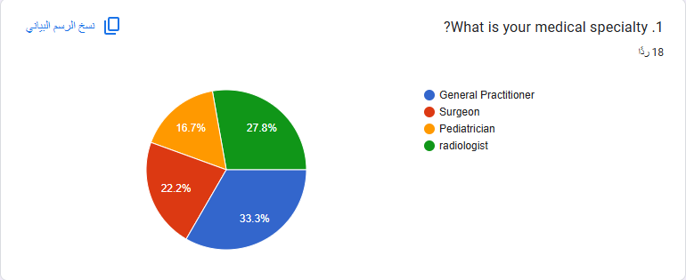

This chart show the specialty of each doctor we can see that the superior numbers going to the general practitioner with a (33%) then radiologist with (27%) after that surgeon with (22%) and lastly pediatrician with (16%) this ensure diversity in the answers from different points of view.

In this chart the experience levels were balanced between 22% for 0-2, 3-5 and 6-10, and a 33% for more than 10years with this distribution I would get insight from young and senior professionals to help me.

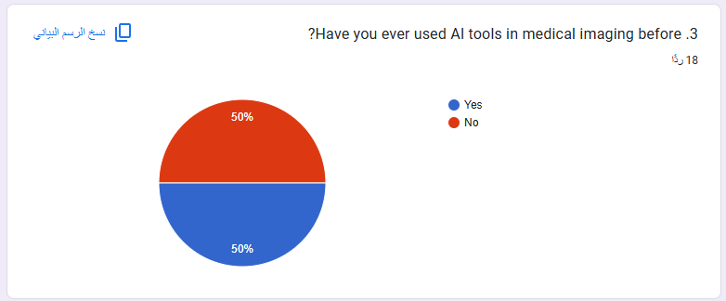

This chart give me an idea of how many doctors have ever used ai in there work and it shows half of them did use it and that would make it a bit more easy to train them more on it instead of starting from zero.

This char show how important is it to retrieve the history of patient and we can see from the chart its all above the positive side with 44% for essential 33% very important and 22% for important so overall it’s a must thing to have to increase efficiency.

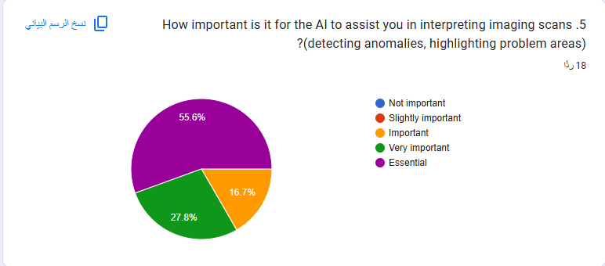

This chart show the percentage of importance of the AI to enhance diagnostics as we can see 55% for essential,27% very important and 16% important.

This chart show 55% essential 38% very important and a small percentage important, so that show us that the integration with the hospital system is top priority.

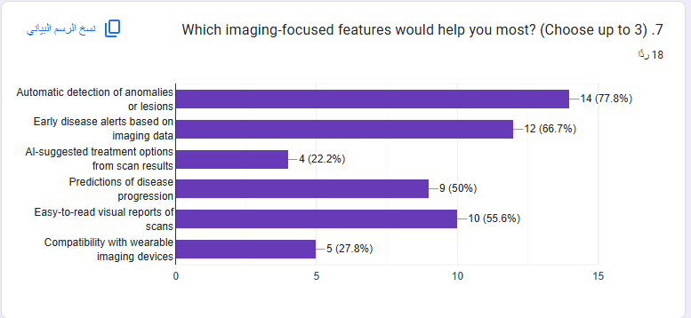

This char show Automatic detection of anomalies at 77%, Early disease alerts based on imaging data at 66% and Easy-to-read visual reports of scans at 55%. This highlights the top 3 features that the doctors would like to see in the AI system.

Here we have another all responses in the positive side with 55% very important 27% essential and 16% important. This show that the AI being user friendly is very welcomed by the doctors.

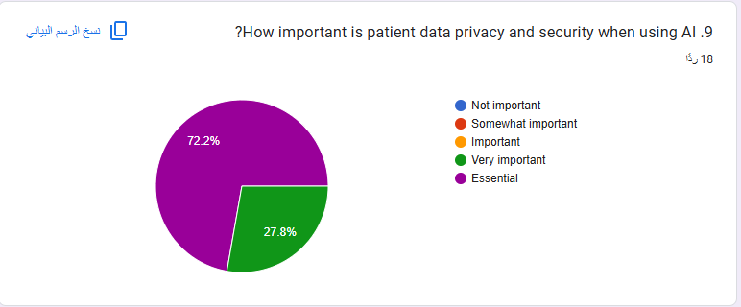

For the privacy and security the vast majority answers with essential 72% and 27 very important as no one would like for his information to be leaked anywhere.

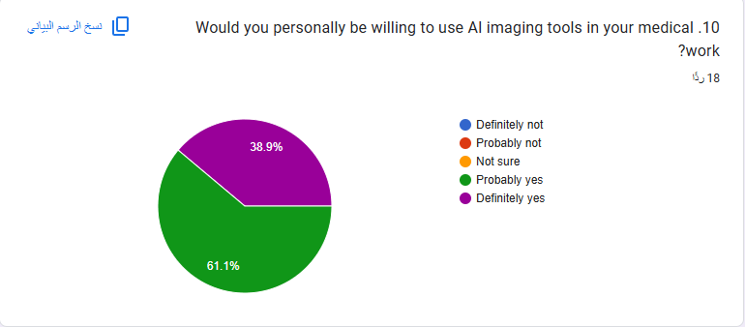

Here we have a 38% are for sure confidant that they will use the ai system but the 61% are ok with using it but they may not this show there is not big trust on it.

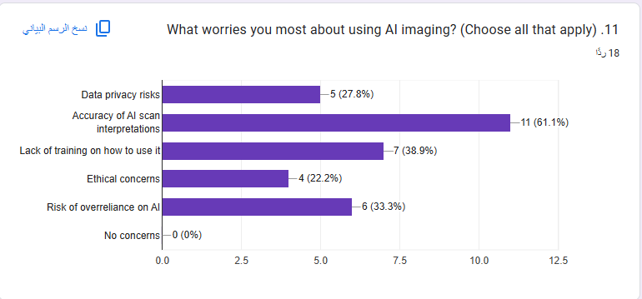

We can see in this chart what is the most feared thing about the ai system we want to implement as 61% are not sure about Accuracy of AI scan interpretations, and 38% are worried as they do not have training on how to use it or anything similar to it and 33% are worried about overreliance on it that would make them lose the edge they have in their career.

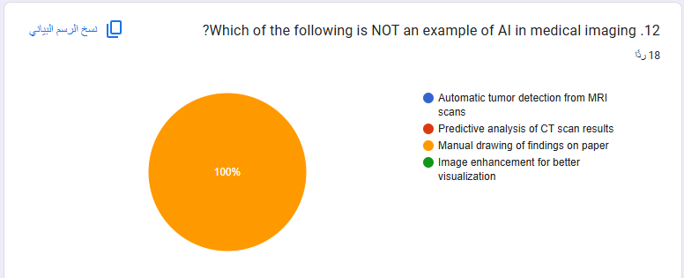this question was added it check that every answer would be done from a professional doctor and not anyone else as it their expertise and allow me to filter any wrong answers from the final collection.

A 100% yes here mean that we can’t rely on ai alone we need to have the human insight on something critical like this.

This chart shows a reliability check with the 13 question to ensure a consistency as it is have the same essence as 13 and the chart show 61% strongly agree and 38% agree that means there is reliability.

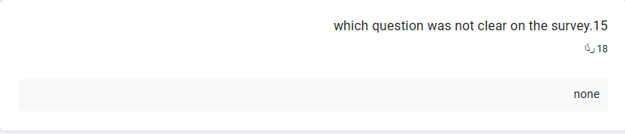

For this question all the answers were the same as they had no problem in any question

As for the optional question I did not get any answer for it.

1. For product requirements question 4, 6 and 8 those questions focus on what the AI system should do and how it should function in hospital environment.
   1. **Q4** – Importance of quickly retrieving patient imaging history.
   2. **Q6** – Importance of integrating seamlessly with hospital imaging systems.
   3. **Q8** – Importance of being simple and easy to use.
2. For product features question 5,7 and 16 those questions specifies tools, functions, and capabilities desired in the AI system.
   1. **Q5** – Importance of AI assisting in interpreting imaging scans.
   2. Q**7** – Most desired imaging-focused features.
   3. **Q16** – Extra features desired.
3. For resistance question 3,10 and 11 those questions are there to find concerns, barriers, or hesitation towards the adoption of the AI system.
   1. **Q3** – Previous use of AI tools in medical imaging.
   2. **Q10** – Willingness to use AI imaging tools.
   3. **Q11** – Main concerns about AI imaging.
4. For accuracy and reliability question 13 and 14 for reliability and question 15 and 12 for accuracy as those questions look into the confidence in ai output and the role of human oversight and look if any of the other questions were not understood clearly.
   1. **Q12** – Identification of a non-AI example in imaging.
   2. **Q13** – Whether a doctor should verify AI diagnosis before acting.
   3. **Q14** – Agreement that AI should only be used with human oversight.
   4. **Q15** –checks for any misunderstood questions.

**Management survey**

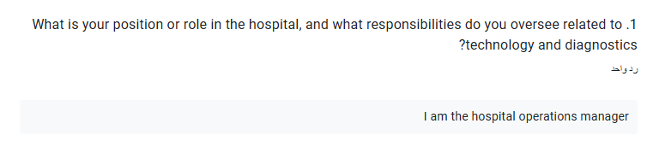

He would be the respondent introducing himself as the operations manager within the hospital, whose function is that of technology and diagnostic emphasis. It is one of the fundamental positions that exist within the hospital's system organization because it involves control of technological infrastructure, integration of equipment, and operational efficiency. Response from one such person carries considerable significance because it is from an innovator who is held directly answerable to sign off on, manage, and guarantee success of innovations in novel technologies within the hospital.

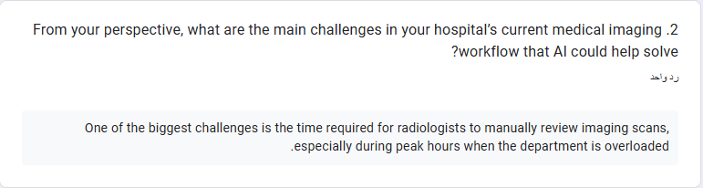

Perhaps one of the largest pain points garnered from today's imaging process in the hospital is that time from radiologists is spent to physically look through and review imaging scans manually. his issue is particularly pronounced during peak hours when the workload is high, leading to potential delays in diagnosis and treatment. Such a pain point creates an urgent need to automate image inspection in an effort to ease radiologist workload, quicken diagnosis time, and enhance patient throughput rates during peak hours.

Hospital administration identified a number of the most important features of the suggested AI imaging solution. Simple-to-read and simple-to-understand reporting to physicians, simple-to-use anomaly detection, predictive analytics for illness for prognosis, and integration with current PACS and EHR software were some of the features that were mentioned. All this would mean that, aside from making diagnosis easier, the AI solution would be seamlessly integrated with current hospital workflow without delay and with great usability.

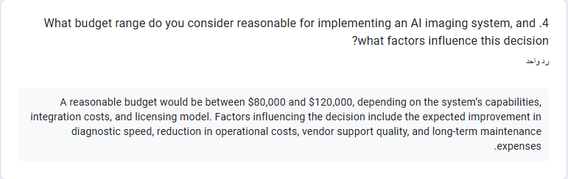

Management said an ideal budget would be from $80,000 to $120,000 and that budget would be an all-inclusive sum on system capability, cost of integration, licencing, and maintenance. The budget allocation shall be decided to a large extent how soon faster diagnostic time shall be improved, how much money shall be saved on operations, how much third-party support shall be achieved from vendors, and how much in advance shall be cost-saving replacing and upgrading this system, it also depends on from which vendor the equipment would be bought.

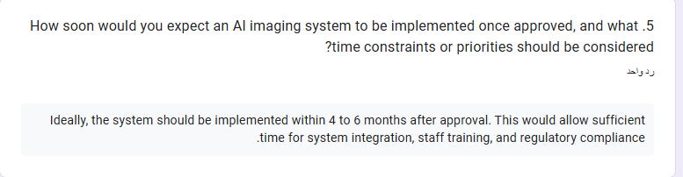

The preferred implementation timeline for the AI imaging system is 4 to 6 months following project approval. This timeline is intended to provide sufficient time for seamless integration with current hospital systems, comprehensive staff training, and compliance with regulatory requirements. The timeline also reflects a desire to implement the system efficiently without causing disruptions to ongoing operations or compromising the quality of patient care during the transition.

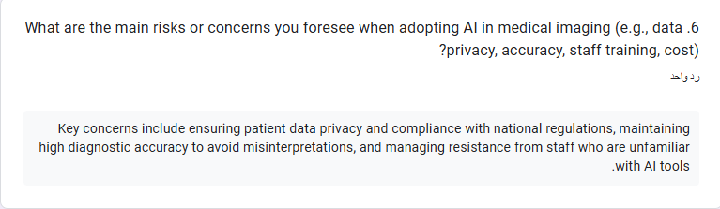

Primary issues and concerns about applying AI in medical imaging are patient information security, AI accuracy in diagnosis, and potential resistance from employees who do not grasp AI devices. The concerns make it paramount to be sure that the system adheres to data security rules, ensures robust verification precision mechanisms, and is implemented with robust employee training programs in an effort to instill confidence and knowledge within employees.

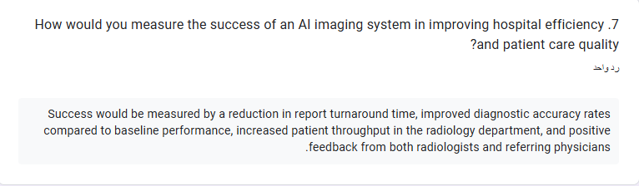

Management stated that the success of the AI imaging system would be measured through tangible performance indicators. These include a reduction in report turnaround time, improvement in diagnostic accuracy rates, an increase in patient throughput in the radiology department, and positive feedback from both radiologists and referring physicians. These criteria will serve as benchmarks to assess the system’s real-world impact on hospital efficiency and quality of care.

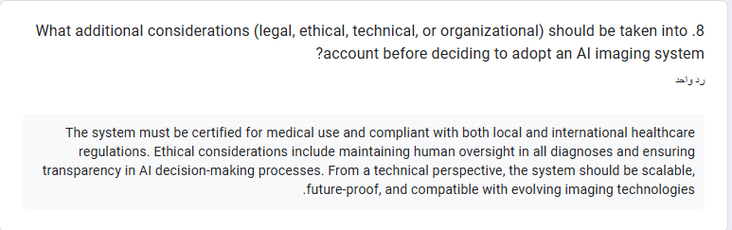

Other factors for rolling out the AI imaging technology are whether the technology is conformant with all legal and ethical requirements, scalable to address increasing future hospital demands, and compatible with future imaging technologies. Technical factors are ensuring the system is future-proof and allowing for adaptation to changing medical imaging protocols and future technology advances. Ethical factors are the requirement for human oversight of diagnostic decision and transparency in the manner in which the AI makes the decision.

1. Product Requirements Focuses on operational needs, scope, budget, and time constraints for implementing the AI system  
   1. Q3 – Expected features of an AI imaging system  
      This question provides insight into what the hospital considers essential for an AI imaging tool to be viable. Responses included automatic anomaly detection, predictive analytics, user-friendly reports, and seamless integration with PACS/EHR. These define the baseline functional requirements the AI must meet to be adopted.
   2. Q4 – Budget range and influencing factors  
      This question determines the financial boundaries for the project, establishing a range of $80,000–$120,000. Factors influencing the budget—such as diagnostic speed, operational cost reduction, and vendor support—help prioritize features that offer the best return on investment.
   3. Q5 – Implementation timeline and priorities  
      This question identifies the timeframe constraints for the project, with the hospital preferring a 4–6 month rollout. It also reveals priorities, such as allowing adequate time for staff training, integration, and regulatory approvals, which are essential for smooth implementation.
2. Product Features Details specific tools, functionalities, and technical expectations for the AI system
   1. **Q3 – Expected features of an AI imaging system** (overlaps with Product Requirements)  
      Beyond defining needs, this question specifies the **technical features** management expects—such as urgent case prioritization and predictive capabilities—making it relevant to both requirements and features.
   2. **Q8 – Additional considerations**  
      This question captures **technical and strategic features** beyond basic functionality, including scalability for future needs, compliance with legal and ethical standards, and compatibility with emerging imaging technologies. These are **long-term operational features** that ensure the system remains relevant.
3. Resistance Identifies barriers that could prevent successful adoption of the AI system  
   1. **Q6 – Main risks or concerns when adopting AI in medical imaging**  
      This question directly addresses **adoption challenges**, such as staff resistance, concerns over AI accuracy, and patient data privacy. Responses indicate areas where implementation planning must focus on change management, staff engagement, and robust data protection measures.
4. Accuracy & Reliability this part is for the doctors survey nothing for management one.

**Secondary Research Analysis**

To strengthen the insights drawn from the surveys, a review of five authoritative publications was carried out. These sources examine how Artificial Intelligence is being introduced into healthcare settings, with a particular emphasis on its role in medical imaging. The intention was to see whether the published evidence matches the practical needs and expectations identified in the doctor and management feedback.

One article in Mayo Clinic Proceedings: Digital Health outlines how AI tools, when embedded into everyday workflows, have reduced documentation time and eased the mental load on clinicians. For imaging departments, the benefits extend to quicker access to past scans, more consistent reporting, and a greater focus on patient interaction. The authors note, however, that if such systems are not well integrated, they risk adding friction rather than efficiency. This observation mirrors many of the survey comments stressing the need for AI to fit seamlessly into existing PACS and EHR systems.

A feature in the Financial Times offers practical case studies from hospitals already experimenting with AI. The examples include speeding up stroke diagnosis and identifying rare conditions sooner. What stood out in these accounts was that AI acted as an assistant, not a substitute, for professional judgment. This view was echoed by both doctors and management in the surveys, who agreed that AI output should be double-checked by clinicians.

The PubMed review took a broader view, compiling results from multiple studies on AI use in clinical decision-making, hospital operations, and continuous patient monitoring. The section on imaging confirmed that AI can help increase diagnostic precision and shorten report turnaround times, but also warned of barriers such as poor data quality and the steep learning curve for new users. Similar concerns appeared in the primary research, particularly around the need for targeted training.

An ethical perspective was provided by a BMC Medical Ethics scoping review, which mapped the recurring issues raised by AI in medicine. Data governance, fairness, explainability, and accountability emerged as central themes, with radiology given as a prime example where these values must be safeguarded. The connection to the primary findings is clear—survey respondents repeatedly flagged data privacy and the need for transparent AI reasoning as high-priority issues.

Lastly, a Archives of Public Health paper examined risks to patient rights and safety, ranging from potential confidentiality breaches to algorithmic bias and unclear decision paths. The authors urged that any AI tool be clinically validated, adhere to interoperability standards such as DICOM, and meet local regulatory requirements before rollout. These points parallel the hospital management survey responses, which placed heavy emphasis on formal certification and compliance before adoption.

Taken together, the literature paints a consistent picture: AI in imaging holds significant potential to improve accuracy and speed, but its success depends on careful integration, solid training plans, strong governance, and ongoing human oversight. These external findings reinforce and expand on the priorities identified through the surveys, offering a reliable evidence base for shaping the proposed system.

**Combined Insights from Primary and Secondary Research**

Both in questionnaire findings and in papers reviewed, there are several strands of commonality in the successful implementation of AI in medical imaging. Both point to a requirement for seamless integration into already installed hospital systems in order that tools of AI support and do not interfere with work flows. Precision and reliability are repeatedly called for as non-negotiables, with a corresponding emphasis on ensuring human validation of AI outputs. In addition, there is an overall consensus on the value added by automatic detection of anomalies, by predictive modeling, and by reader-friendly reporting, features seen directly to increase diagnostic efficiency. Challenges posed in both sources—security of data, value of focussed training, and caution on the part of staff by those who are new to AI—sound out the need for a robust implementation and change management plan. Lastly, concordance between primary and secondary research serves to underscore that even as there are certain promises to be made of AI to re-engineer the imaging service, true success will arrive in the tension of weighing technological potentialities against protections of ethics, statutes and regulations, and vigilant buy-in of the stakeholder base.

## **Research Findings**

**Alignment with Core Business Requirements**

As seen in surveyed answers and previous research articles, our suggested AI-driven medical image software is right in line with the hospital’s overall objectives. Both management and the healthcare professionals pointed to having one system that would integrate well in the current installations of PACS and EHR, where the manpower wouldn’t have to toggle back and forth between isolated units. The articles that I read provide just the same: if AI’s not to be integrated in the workflow, then instead of speeding things up, it may decelerate.

Budget Feasibility and Financial Impact

From a financial perspective, $80,000–$120,000 was a reasonable budget but only if the expenditure would be worthwhile with alterations that could be measured—faster diagnoses, less manpower, and less operating expenses in the long term. This is evidenced by literature, indicating such similarly high-ranked hospitals applied similar AI systems in such a budget range when integration, training, and administrative clearances were included in the plan. This indicates the suggested budget to be reasonable based on real-life examples and not an optimistic estimate.

**Timeline and Implementation Planning**

Optimal time frame—4 to 6 months—also matches what I read in the literature, that the vast majority of hospitals can implement AI imaging technologies in 4 to 9 months if they plan the implementation on a phased timeline. That provides enough time to implement, to train, and to complete all of the quality and regulatory testing without having to rush. That should also prevent the typical last-minute glitches that would result if training or certification were delayed until later.

**Technical Specifications and Quality Standards**

All the survey responses and literature concur on the identical technical specifications: the system must be scalable to future imaging modalities, highly accurate, world-wide standard compliant as DICOM, and always include a human in the decision loop to provide the final decision. Such requirements are not desirable requirements but minimum requirements to render the system pertinent, dependable, and safe to employ in a clinical environment.

**Challenge 1: Reducing Scan Interpretation Time(Market Competition and Patient Expectations from 2.4)**

One of the hospital's largest challenges is scan interpretation and review time during high-traffic hours. AI can make an enormous impact here by revealing critical cases and indicating probable areas of trouble in the images. It's not just theory, either—tests have shown that hospitals utilizing AI for this purpose have been decreasing reporting time and boosting patient throughput, and particularly under high-stress conditions such as emergency care.

**Challenge 2: Overcoming Staff Resistance(Change Management and Staff Adaptation frp, 2.4)**

The second barrier is having staff fearful—actually skeptical—of new technology. Surveys showed that fear always had one of two causes: ignorance about how the system itself works, or fear of job replacement. In research, there are pragmatic solutions: phase in the system in stages, give hands-on training, and be explicit in saying AI is there to help, not to replace. These actions have helped other hospital administrators overcome fears and galvanize staff in a brief time.

**Addressing Privacy and Compliance Risks(Compliance with Legislation and Industry Standards)**

Another area where both data sources line up is in stressing patient data security and regulatory compliance. Setting up strong data protection protocols and making sure the system meets Ministry of Health requirements from day one will not only prevent legal or ethical issues but also boost confidence among both staff and patients.

**Overall Conclusion**

Bringing everything together, the surveys and the secondary research all point in the same direction. The suggested AI imaging system aligns with the hospital’s budget, timeline, and technical constraints and has positive chances to face its greatest challenges in well-defined ways. In balancing what works in theory with what is essential in practice, the project has positive chances to succeed and be well-accepted throughout the organization.

# **References**

1. IBM (2024) What is Artificial Intelligence (AI)?. Available at: https://www.ibm.com/topics/artificial-intelligence (Accessed: 05 August 2025).
2. Mayo Clinic Proceedings: Digital Health (2024) Transforming Health Care With Artificial Intelligence. Elsevier. Available at: <https://www.mcpdigitalhealth.org/article/S2949-7612%2824%2900041-5/fulltext> (Accessed: 05 August 2025).
3. Financial Times (2024) The doctors pioneering the use of AI to improve outcomes for patients. Financial Times. Available at: <https://www.ft.com/content/2fd63023-ec0a-421c-9abb-b6c8000b3b51> (Accessed: 05 August 2025).
4. Varnosfaderani, M. et al. (2024) The Role of AI in Hospitals and Clinics. National Library of Medicine, PubMed. Available at: <https://pubmed.ncbi.nlm.nih.gov/37651022/> (Accessed: 05 August 2025).
5. Ratti, E. et al. (2025) Ethical and social considerations of applying artificial intelligence in healthcare: a scoping review. BMC Medical Ethics. Available at: <https://bmcmedethics.biomedcentral.com/articles/10.1186/s12910-025-01198-1> (Accessed: 05 August 2025).
6. Botha, A. et al. (2024) Artificial intelligence in healthcare: a scoping review of perceived threats to patient rights and safety. Archives of Public Health. Available at: <https://archpublichealth.biomedcentral.com/articles/10.1186/s13690-024-01414-1> (Accessed: 05 August 2025).
7. Spectral AI (2024). *Artificial Intelligence in Medical Imaging | AI in Imaging*. [online] SpectralAI. Available at: <https://www.spectral-ai.com/blog/artificial-intelligence-in-medical-imaging/>.
8. ‌ Daley, S. (2023). *AI in healthcare: Uses, examples and benefits*. [online] Built In. Available at: https://builtin.com/artificial-intelligence/artificial-intelligence-healthcare.
9. ‌ Sand Technologies. (2025). *Efficiency Meets Equity: How AI is Transforming Healthcare Delivery*. [online] Available at: https://www.sandtech.com/insight/ai-operational-efficiency-in-healthcare/?utm_source=chatgpt.com [Accessed 6 Aug. 2025].
10. ‌DICOM. (n.d.). *Current Edition*. [online] Available at: https://www.dicomstandard.org/current.